Research article

PECTINASE-ASSISTED EXTRACTION OF PHENOLIC COMPOUNDS FROM POLYGONUM MULTIFLORUM THUNB. ROOT

ABSTRACT
The objective of this study was to figure out the optimal conditions for polyphenol extraction from Polygonum multiflorum Thunb. roots using pectinase-assisted extraction method. In this research, total phenolic contents (TPC) were determined by the Folin Ciocalteu method and antioxidant capacity (AC) was analyzed by free radical scavenging activity method with Trolox and DPPH as standard reagents. They were describe by gallic acid equivalent (GAE) and Trolox equivalent (TE), respectively. We examined factorials that gave the highest total phenolic content and strongest antioxidant capacity including material/solvent ratio (1/5 - 1/13), enzyme concentration (0.1% - 0.5%), extraction time (40 - 120 minutes), pH (3.5 - 5.5) and extraction temperature of (30ºC - 70ºC). The optimal extraction conditions achieved such as the material/solvent of 1/11 (w/v), enzyme concentration of 0.2% (v/w), extraction temperature at 50ºC, pH at 4.5, extraction time at 80 minutes. TPC and AC peaked at 44.36 mg GAE/g DW (dry weight) and 80.43 μmol TE/g DW. After treatment, the materials were changed strongly and were also observed by scanning electron microscopy (SEM). Some extractive compounds of phenolic such as gallic acid and catechin were determined by HPLC method.

Keywords:
Antioxidant capacity
Extraction
HPLC
Pectinase
Polyphenol

1. Introduction
From the late 20th century, the studies showed that long-term used of plant food containing many polyphenols can prevent cardiovascular diseases, chronic inflammation, degeneration, even though cancer diseases. Because of the great effect on health, polyphenols have been extracted into functional food to support human health. The plentiful polyphenols have been found in plants, especially in Polygonum multiflorum Thunb. (In Vietnam, it name Ha thu o do - HTOD). It was one of the precious plants that containing a considerable amount of phenolic compounds. The roofs of HTOD are used widely as an herb or tonic to treat hair loss, malaria and added essential substances in the blood, antioxidant liver cells. The extracted compound from HTOD had antioxidant effects, anti-ageing (Kwon et al., 2009) and anticancer (Milner et al., 1994). At the present, there are more than 100 chemical compounds that have been isolated from HTOD and major components with high biological activity have been identified such as stilbenes, quinones, flavonoids, emodin and other substances (Lin et al., 2015).
There are many methods to extract phenolic compounds from plants such as using microwave, ultrasonic, supercritical fluid, high hydrostatic pressure, soxhlet extraction, etc. (Khoddami et al., 2013). Each extraction method has the advantage and weakness. Meanwhile, enzyme-assisted extraction is good effect for plants for instant pectinase. It has been widely applied in food technology to increase the extraction efficiency for phenolic compounds, as in apple (Zheng et al., 2009), grape seaweed (Ngô et al., 2014), mulberry (Nguyen et al., 2014), etc. Pectinase can hydrolyze pectin, break the cell wall and promote the liberation of the components inside the material. In addition, using pectinase do not require complex equipment, environmentally friendly and high yield. Nowadays, there are no studies showed pectinase-assisted method for the extractive compounds of phenolic from HTOD. Thus, we determine the appropriate conditions for extractive process including the ratio meterial/solvent, enzyme concentration, pH, time and extraction temperature from HTOD.
2. Materials and methods
2.1. Materials
2.1.1 Plant material and sample preparation
Polygonum multiflorum Thunb. roots were collected from Cao Bang province (Vietnam). The fresh roots have the weight range from 0.5 to 1 kg, reddish brown color, no diseased or physical injuries. The cleaned roots were sliced into 2-3 mm thick pieces and dried at 60ºC until <13% of moisture. The dried samples were ground into a fine powder (<0.5 mm), packaged in vacuum condition and stored at room temperature for further use.
2.1.2 Chemical and reagents
Pectinase (Pectinex Ultra SP-L) was purchased from Novozyme Company (Denmark). Folin–Ciocalteu (FC) and DPPH (1,1–Diphenyl–2– pricrylhydrazyl) reagent was purchased from Merck (Germany). Trolox (6-hydroxy-2,5,7,8-tetramethylchroman-2-carboxylic acid) reagent was purchased from Sigma-Aldrich (USA) and other chemicals were of analytical reagent grade.
2.2. Methods
2.2.1 Extraction of phenolic compounds
The root powder (2 g) was extracted with the assistance of pectinase. Extraction of phenolic compounds was tested at different material/solvent ratios (1/5, 1/7, 1/9, 1/11 and 1/13, w/v), pectinase concentrations (0.1, 0.2, 0.3, 0.4 and 0.5%, v/w), extraction times (40, 60, 80, 100 and 120 minutes), pH (3.5, 4, 4.5, 5 and 5.5) and extraction temperatures (30, 40, 50, 60 and 70ºC). The mixture was ﬁltered through Whatman No.4 filter paper in vacuum and TPC and AC were then analyzed.
2.2.2 Determination of total polyphenol content (TPC)
The TPC in the extracts was slightly modified and determined by the Folin-Ciocalteu colorimetric method (Premakumari et al., 2010). The results were based on a standard curve obtained with gallic acid. TPC were expressed as mg of gallic acid equivalents per gram of dry weight (mg GAE/g DW).
2.2.3 Determination of antioxidant capacity (AC)
The AC in the extracts was determined by DPPH assay; this method was slightly modified and described by Soto et al. (2014). Trolox was used as the standard. AC was expressed in TEAC (Trolox equivalent antioxidant capacity) determined as μmol of Trolox per gram of dry weight (μmol TE/g DW).
2.2.4 Scanning electron micrographs (SEM)
Scanning electron microscope system (Jeol JSM-6480LV, Japan) was used to examine morphological of dried powder before and after enzyme treatment.
2.2.5 Determination of phenolic compounds by High Performance Liquid Chromatography method (HPLC)
HPLC analysis of phenolic compounds in extracts was carried out on an Agilent 1100 Series HPLC system equipped a diode-array UV-vis detector. The analysis was performed on a reversed-phase column (ACE C18, 4.6 × 150 mm, 3.5µm); the sample was injected into the injection port (loop 20 μL). The UV detector was set at a wavelength of 270 nm and 308 nm for gallic acid, catechin and resveratrol, respectively.
2.3. Data analysis
Results were analyzed by one-way analysis of variance (ANOVA) method and significant differences among means from triplicate analyses at (p<0.05) were determined by Fisher's least significant difference (LSD) procedure using the Statgraphics software (Centurion XV).
3. Results and discussions
3.1. Effect of the ratios material/solvent on the extraction of phenolic compounds
Dried powder was extracted by the same extraction conditions including pectinase concentration of 0.2% (v/w), temperature of 50ºC, pH of 4.5, extraction time of 100 minutes and different material/solvent ratios. Figure 1 showed that using material/solvent ratio of 1/11 had the optimal results; TPC and TEAC of extracts had significant differences (p_{value}<0.05) and reached 41.62±0.98 mg GAE/g DW and 79.13±0.29 μmol TE/g DW, respectively.
During the extraction, phenolic compounds moved into solvents that based on the diffusion. When the amount of solvent increases, the efficiency will also improve (Vũ and Hà, 2009). If amount of solvent is too low, phenolic compounds will not diffuse completely into solvent. Thus the extractive efficiency will decrease. However, the high volume of solvent can dilute the extract; the obtained yield is negligible and would not be cost effective. Based on the received results, the ratio of material/solvent 1/11 will use for the next experiment.
3.2. Effect of pectinase concentrations on the extraction of phenolic compounds
According to figure 2, pectinase concentration of 0.2% was the best result, TPC and TEAC have the optimal values with 43.92±0.04 mg GAE/g DW and 76.96±0.26 µmol TE/g DW, respectively; and effect of pectinase concentration on the values of TPC and TEAC have a significant differences (p_{value}<0.05).
At first, pectinase hydrolyzes pectin in the materials, decomposes the structure of cell plants, reduces the viscosity of the solution and releases the substances inside the cell, especially phenolic compounds. Therefore, the yield of extraction can improve quickly. As enzyme concentration increases, the reaction rate also increases, when the concentration of enzyme achieves the saturation, then the velocity the reaction does not change (Lê et al., 2002). Hence, TPC and TEAC increase insignificantly and maybe decrease because some phenolic compounds made the complexes with protein and inhibit enzymes (Begon et al., 1989). Pectinase concentration in this study is lower than some other studies, for instance Zheng et al. (2008) suggested that the level of pectinase up to 12% can increase the recovery yield of polyphenols from apple pomace, Ngô et al. (2014) used 5.63% pectinase concentration to extract polyphenol from seagrape (Caulerpa lentillifera). Based on the above results, pectinase concentration of 0.2% was chosen for the evaluation of next steps.
3.3. Effect of extraction time on the extraction of phenolic compounds
The extraction time was researched from 40 to 120 minutes. The figure 3 shows that the highest TPC and TEAC were 44.02±0.77 mg GAE/g DW and 77.99±0.12 µmol TE/g DW at the extraction time of 80 minutes. Effect of extraction times on the yield have a significant difference (p_{value}<0.05). TPC and TEAC tend to increase with increasing extraction time from 40 to 80 minutes then drops slightly from 80 to 120 minutes.
Extraction time is an important factor that influences on the extraction process. The optimal extraction time can save cost and time of process. In the other hand, increased extraction time is not effective but it can waste more time-consuming, reduces the economic and efficient use of the device. Most of the bioactive compounds are sensitive to high temperature, and their long storage will lead to the decomposition of bioactive compounds, especially phenolic compounds. They are oxidized by environmental factors such as light, temperature and oxygen. Extraction time depends on materials, extraction methods, devices and phenolic compounds. In this study, the extraction time was shorter than polyphenol extraction by pectinase from the seagrape (Caulerpa lentillifera) (102 minutes) (Ngô et al., 2014) and viscozyme L from unripe apples (12 hours) (Zheng et al., 2009), but it was longer than that of polyphenol extraction by microwave-assisted extraction (5 minutes) and ultrasound-assisted extraction (20 minutes) from melissa (Ince et al., 2013). Based on the achieved results, the optimal extraction time was 80 minutes for extraction process.
3.4. Effect of pH on the extraction of phenolic compounds
The optimal value of TPC and TEAC were shown in figure 4 and effect of pH on TPC and TEAC had a significant difference (p_{value}<0.05). The highest TPC and TEAC obtained were approximately 45.05±0.63 mg GAE/g DW and 82.21±0.2 μmol TE/g DW at pH of 4.5, respectively.
The pH affected significantly the degree of ionization of substrates and enzymes (Lê et al., 2002). Besides that, due to the fact that the optimal operating conditions of pectinase are at pH of 4.5, TPC and TEAC were higher than the others, that means polyphenol in root of HTOD was stabled at pH<7 and could be unstable at pH>7. This results were similar with research of Zhu et al. (1997) who recognized that catechins in green tea was extremely unstable and decomposed almost completely in few minutes at pH> 8, while it was very stable at pH <4 (Zhu et al., 1997). Moreover, Friedman and Jurgens (2000) also demonstrated that caffeine, chlorogenic, and gallic acid of plants were unstable at high pH. Thus, the optimal pH of 4.5 is selected for the next survey.
3.5. Effect of temperature on the extraction of phenolic compounds
The analyzed results showed that the temperatures had a significant effect on extracting the phenolic compounds (p_{value}<0.05). According to figure 5, the maximum values of TPC and TEAC were 44.36±1.87 mg GAE/g DW and 80.43±0.13 μmol TE/g DW at 50ºC, respectively.
As extraction temperature increases from 30ºC to 50ºC, the values of TPC and AC also increase. The high temperature can promote the diffusion of phenolic compounds, reduces the viscosity of the solvent and easily releases phenolic compounds. However, when the temperature rose over 50ºC, the TPC and TEAC decline extremely because they are quite sensitive with heat treatment. Besides that, the temperature also had a strong influence on enzyme reactions. Enzyme activity increased in a certain temperature limit; if it exceeds the limit, the enzyme activity will reduce (Nguyễn et al., 2004) and high temperature leads to a decrease in the value of TPC. Based on the achieved results, the optimal extraction temperature was 50ºC.
3.6 Effect of pectinase-assisted extraction on the structure of material and content of some phenolic compounds
Figure 6 shows that initial materials consist of many pieces of cell plants and starch that has many different diameter and egg (or oval) shape. After treatment by pectinase, almost of starch was not gelatinized at 50ºC and a large number of wrinkles and fragments appear on surface of cell wall because the cell wall was destroyed by pectinase. It made the easy condition to release phenolic compounds.
Using HPLC method identified some phenolic compounds from the extracts at the optimal conditions. The detected phenolic compounds were gallic acid (3.65 mg/g), catechin (1.56 mg/g) (Figure 7, 8). Detecting these components are similar with research of Chen et al. (1999) but resveratrol in this study was not detected (Figure 9, 10) although there are many research proved that this compound also existed in HTOD extract (Quoc and Muoi, 2016; Chang et al., 2016). This difference was explained by many factors that could affect the content of phenolic compounds including extraction method, material, gene, climate, soil…
4. Conclusions
The results pointed out that the support of pectinase can improve extraction process of phenolic compounds from Polygonum multiflorum Thunb. roots. The highest TPC and AC in the extract were 44.36±1.87 mg GAE/g DW and 80.43±0.13 µmol TE/g DW, respectively. The optimal conditions of extraction process were material/solvent of 1/11, pectinase concentration of 0.2%, pH of 4.5, extraction time of 80 minutes and extraction temperature of 50ºC. Cells of material were destroyed by enzyme pectinase and there are some main phenolic compounds which were detected as catechin, gallic acid.

5. References
Begon, M., Fitter, A. H., Ford, E. D., Macfadyen, A. (1989). Advances in Ecological Research, Academic Press, New York, (Part 5, chapter III).
Chang, Y.X., Ge, A.H., Jiang, Y., Azietaku, J.T., Li, J., Gao, X.M. (2016). A Bioactivity-Based method for Screening, Identification of lipase inhibitors, and Clarifying the effects of processing time on lipase inhibitory activity of Polygonum Multiflorum. Evidence-Based Complementary and Alternative Medicine, 2016, 1–10.
Chen, Y., Wang, M., Rosen, R.T., Ho, C.T. (1999). 2,2-Diphenyl-1-picrylhydrazyl radical scavenging active components from Polygonum multiflorum Thunb. Journal of Agricultural and Food Chemistry, 47(6), 2226-2228.
Friedman, M., Jurgens, H. S. (2000). Effect of pH on the Stability of Plant Phenolic Compounds. Journal of Agricultural and Food Chemistry, 48(6), 2101-2110.
Ince, A. E, Sahin, S., Şumnu, S. G. (2013). Extraction of phenolic compounds from melissa using microwave and ultrasound. Turkish Journal of Agriculture and Forestry, 37(1), 69-75.
Khoddami, A., Wilkes, M. A., Roberts, T. H. (2013). Techniques for Analysis of Plant Phenolic Compounds. Molecules, 18, 2328-2375.
Kwon, B. M., Kim, S. H., Baek, N. I., Lee, S. I., Kim, E. J., Yang, J. H., Chae, B. S., Lee, J. H., Park, H. W., Park, J. S., Kim, D. K. (2009). Farnesyl protein transferase inhibitory components of Polygonum multiflorum. Archives of Pharmacal Research, 2(4), 495-499.
Lê, N. T., Lê, V. C., Đặng, T. T., Phạm, Q. T., Lưu, D., Nguyễn, T. T., Bùi D. H., Lê D. D. (2002). Hóa sinh công nghiệp. Nhà xuất bản khoa học kỹ thuật, Hà Nội, (Chương 1). (In Vietnamese).
Lin, L., Ni, B., Lin, H., Zhang, M., Li, X., Yin, X., Qu, C., Ni, J. (2015). Traditional usages, botany, phytochemistry, pharmacology and toxicology of Polygonum multiflorum Thunb.: A review. Journal of Ethnopharmacology, 159, 158-183.
Milner, J.A. (1994). Reducing the risk of cancer. In I. Goldberg (Ed), Functional Foods: Designer Foods, Pharmafods, Nutraceuticals. (pp. 39-70), Chapman & Hall, Springer, New York, USA.
Ngô, T. T. T., Trần, T. L., Võ, T. K. H., Đống, T. A. D. (2014). Khảo sát hoạt tính chống oxy hóa và hàm lượng polyphenol của dịch trích thô từ rong nho Caulerpa lentillifera có sự xúc tác của pectinase. Tạp chí Khoa học và Công nghệ, 52(5C), 121-126. (In Vietnamese)
Nguyễn, D. L., Cao C., Nguyễn, A. T., Lê, T. T. T., Huỳnh, N. O., Nguyễn, T. H., Phan, T. H., Tạ. T. H. (2004). Công nghệ enzyme. Nhà xuất bản ĐH Quốc gia Tp. HCM, Hồ Chí Minh, (Chương 1). (In Vietnamese)
Nguyen, T. N. T., Phan, L. H. N., Le, V. V. M. (2014). Enzyme-assisted and ultrasound-assisted extraction of phenolics from mulberry (Morus alba) fruit: comparison of kinetic parameters and antioxidant level. International Food Research Journal, 21(5), 1937-1940.
Premakumari, K. B., Siddiqua, A., Sultana, R., Vithya, S. (2010). Antioxidant activity and estimation of total phenolic content of Muntingia Calabura by colorimetry. International Journal of ChemTech Research, 2(1), 205-208.
Quoc, L. P. T., Muoi, N. V. (2016). Microwave-assisted extraction of phenolic compounds from Polygonum Multiflorum Thunb. roots. Acta Scientiarum Polonorum Technologia Alimentaria, 15(2), 181-189.
Soto, C., Caballero, E., Pérez, E., Zúñiga, M. E. (2014). Effect of extraction conditions on total phenolic content and antioxidant capacity of pretreated wild Peumus boldus leaves from Chile. Food and Bioproducts Processing, 92(3), 328-333.
Vũ, H. S., Hà, D. T. (2009). Nghiên cứu trích li Polyphenoltừ chè xanh vụn. Phần 1: Các yếu tố ảnh hưởng đến quá trình trích li polyphenol. Tạp chí khoa học và công nghệ, 47(1), 81-86. (In Vietnamese)
Zheng, H. Z, Lee, H. R., Lee, S. H., Kim, C. S., Chung, S. K. (2008). Pectinase assisted extraction of polyphenol from apple pomace. Chinese Journal of Analytical Chemistry, 36(3), 306-310.
Zheng, H. Z., Hwang, I. W., Chung, S. K. (2009). Enhancing polyphenol extraction from unripe apples by carbohydrate-hydrolyzing enzymes. Journal of Zhejiang University Science B, 10(12), 912-919.
Zhu, Q. Y., Zhang, A., Tsang, D., Huang, Y., Chen, Z. Y. (1997). Stability of green tea catechins. Journal of Agricultural and Food Chemistry, 45(12), 4624-4628.

Acknowledgments
This study was performed at Institute of Biotechnology and Food Technology, Industrial University of Ho Chi Minh City (Vietnam). I would like to acknowledge my coworkers who help me a lot in laboratory, including Dao Thi Thuy Hang, Dao Truc Linh, Nguyen Tran Ngoc Mai, Phan Thi Thanh Truc and Dr. Tran Thanh Truc.

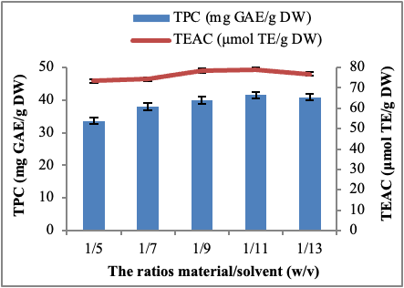
Figure 1. Effect of the ratios material/solvent on the extraction of phenolic compounds
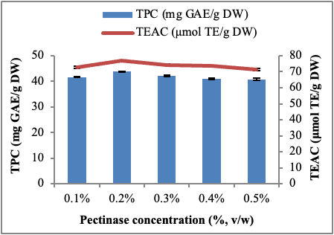

Figure 2. Effect of pectinase concentrations on the extraction of phenolic compounds

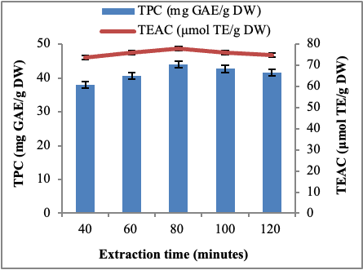

Figure 3. Effect of extraction time on the extraction of phenolic compounds

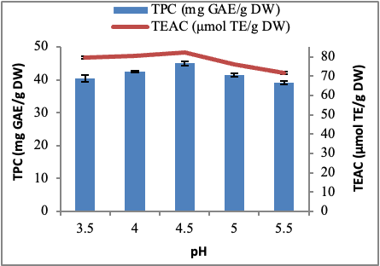

Figure 4. Effect of pH on the extraction phenolic compounds

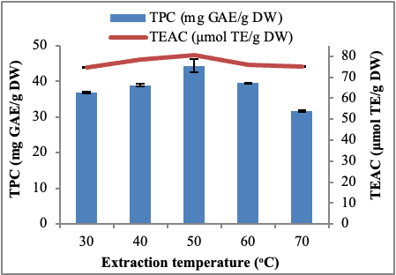

Figure 5. Effect of temperature on the extraction phenolic compounds



Figure 6. Structure of material before (A) and after (B) treatment by pectinase

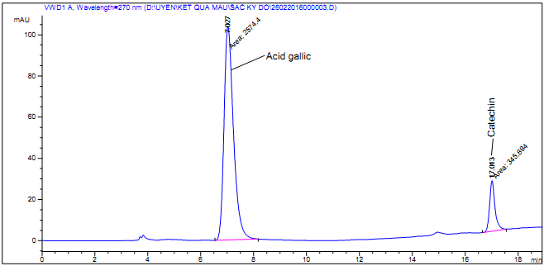

Figure 7. HPLC chromatograms of standard sample (Gallic acid and catechin) acquired at 270 nm

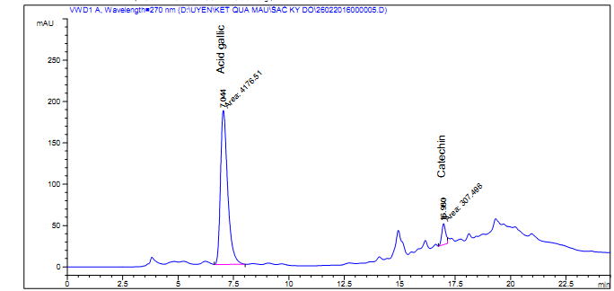

Figure 8. HPLC chromatograms of a sample of Polygonum multiflorum Thunb. root extracts acquired at 270 nm

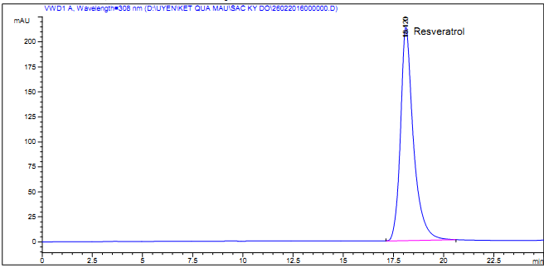

Figure 9. HPLC chromatograms of standard sample (Resveratrol) acquired at 308 nm

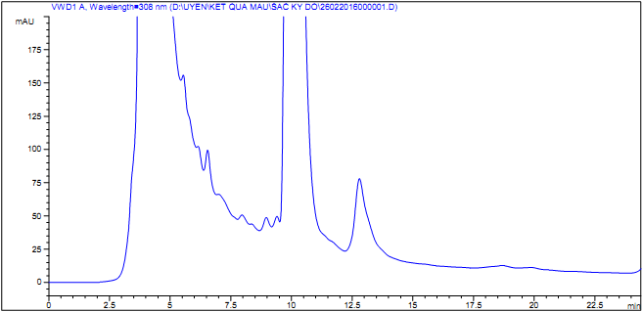

Figure 10. HPLC chromatograms of a sample of Polygonum multiflorum Thunb. root extracts acquired at 308 nm

